IES-TEXA Social Media Approval App — Agency Guide
Last updated: June 15, 2026

What This App Does
The approval app gives IES-TEXA clients a branded portal to review, approve, or request changes on social media posts before they go live. The agency controls the workflow entirely. Clients can only see what you send them.
There are two client tiers:
- Local Client – reviews posts first
- Corporate – final sign-off after local approves

Day-to-Day Workflow

Creating a Post
- Open the agency dashboard
- Click the + button (bottom right)
- Fill in: Title, Post Copy, Platform(s), Scheduled Date
- Add media URLs — see Box tips below
- Status starts as Draft
- Click Save post, the panel closes automatically so you can see the calendar

Box Media URL Tips
The calendar shows an image thumbnail on each post card. For the image to preview, the URL must be a direct-download link, not a standard Box shared link.
Box URL fix: Standard Box shared links use /s/ in the URL. Replace /s/ with /shared/static/ to get the direct-download version.
Example:
- Standard: https://finnpartners.box.com/s/9dr40xm7p32agjtjwvw23nm8zko8taiw
- Direct-download: https://finnpartners.box.com/shared/static/9dr40xm7p32agjtjwvw23nm8zko8taiw
Also for Box links, make sure the Box file is set to “People with the link” and the Link Settings have the Link expiration turned off.
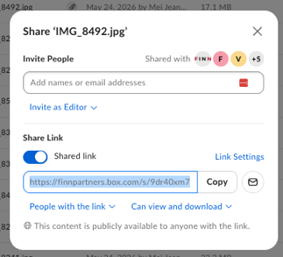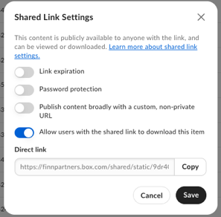
For carousel images, use one URL per line in the Carousel/Additional field. The first URL in any media field is used as the calendar thumbnail.

Sending to Local Client Review
- Edit the post, change Status to Local Client Review
- Click Save post. The panel closes, a notification is queued, and a toolbar badge appears
- When ready to notify the client, click Send to Local Client in the toolbar.
- Finish all posts before sending to Local Client. That way, they get one digest email for the full month rather than one email per post.
- Local clients receive one digest email listing all queued posts
The badge pulses orange with a “⚠️ X ready – send to Local!” label. Don’t skip this step. The LOCAL client receives no email until you click the button.

After Local Approves
When local approves all posts at their stage, each post’s status changes to Send to Corporate (indigo badge). This means local has signed off and the post is ready for corporate, but corporate has not been notified yet.
You can send to corporate from the agency toolbar OR the local client can initiate the send directly from their own portal.
From the agency portal:
- An indigo “⚠️ X ready – send to Corporate!” badge appears in the toolbar
- Click Send to Corporate when ready 3. Corporate receives one digest email listing all posts. Again, do not skip this step. Corporate has not been notified.

After Corporate Reviews
Corporate reviews posts on their own schedule and batches their decisions. They click Send Responses in their portal when done. At that point:
- Local receives a single digest email summarizing all corporate decisions (approved / changes requested / notes)
- Agency receives the same digest sent from AnthologySocial@finnpartners.com
If corporate requested changes on a post, it returns to Revising (teal badge). It’s then in our court. Make revisions, then use the Re-send to Corporate toolbar button to send it back directly to corporate (bypasses local re-review).
Again, do not skip this step. Corporate has not been notified. Click send to corporate AFTER you make all changes so they receive only one email.

Marking Posts Published
On the agency calendar, Approved cards show a Mark Published → button. Click it to mark the post as published and update the calendar.

Status Color Reference
Color | Status | What It Means
Gray | Draft | Not yet shared with any client
Orange | Local Client Review | Awaiting local client decision
Teal | Revising | Agency revising after a change request
Indigo | Send to Corporate | Local approved; waiting to notify corporate
Purple | Corporate Review | Awaiting corporate decision
Green | Approved | All approvals received
Dark Green | Published | Posted live

Toolbar Badge Reference
Badge | What It Means | Action
Orange “⚠️ X ready – send to Local!” | Posts waiting for local client email | Click Send to Local Client
Indigo “⚠️ X ready – send to Corporate!” | Posts local approved; corporate not notified | Click Send to Corporate
Indigo “🔄 X revising (corp)” | Posts in Revising caused by corporate change request | Click Re-send to Corporate

Client Portal Links
I need to set up the Client Portal Links for Ali and Corporate. Will do that once we thoroughly test the app.
Send this link to the client once. They can bookmark it. It never expires unless we change their setup.

Troubleshooting
Symptom | Likely Cause | Fix
Toolbar badge not appearing after client acts | Page needs refresh or batch loader hasn’t run | Badge auto-refreshes every 30 seconds; or reload the page
Post disappears from client portal | Status changed to one not visible at that client’s level | Check post status; may need to re-send
No action buttons in client portal | Client viewing a post not at their action stage | Normal – local acts on Local Client Review; corporate on Corporate Review
Image thumbnail not showing | Box URL uses /s/ (shared link) format | Replace /s/ with /shared/static/in the URL

